**Modern College of Arts Science and Commerce Practical II**

**Bayesian Inference: Credible Interval**

**Date:**

1. Generate a random sample of size *n* = 15 from *B*(10*, θ*) distribution with *θ* = 0*.*45. Assuming that *β*(4*,* 3) is the prior for *θ*.
2. Compute the posterior distribution of *θ*.
3. Plot the posterior density
4. Obtain 95% HPD credible interval for *θ*
5. Generate a random sample of size *n* = 20 from Poisson distribution with *θ* = 1*.*52. Let the prior pdf of *θ* be given by

*f* (*θ*) = 4*θ*exp*{−*2*θ}; θ>0*

1. Compute the posterior distribution of *θ*.
2. Plot the posterior density
3. Obtain 95% HPD credible interval for *θ*
4. Generate a random sample of size *n* = 30 from Normal distribution with mean *θ* = 2*.*6 and variance 1. Let *N* (1*,* 1) be the prior pdf of *θ*. Find the posterior distribution of *θ*.
5. Compute the posterior distribution of *θ*.
6. Plot the posterior density
7. Obtain 95% HPD credible interval for *θ*
8. Generate a random sample of size *n* = 30 from *U* (*−θ, θ*) with *θ* = 2*.*2. Let the prior pdf of *θ* be given by

2

*f* (*θ*) = *θ*3 *θ >* 1

1. Compute the posterior distribution of *θ*.
2. Plot the posterior density
3. Obtain 95% HPD credible interval for *θ*

> #Q1

> n=15

> m=10

> x=rbinom(n,m,0.45)

> a=seq(0,1,length=100)

> a

[1] 0.00000000 0.01010101 0.02020202 0.03030303 0.04040404 0.05050505 0.06060606 0.07070707 0.08080808 0.09090909

[11] 0.10101010 0.11111111 0.12121212 0.13131313 0.14141414 0.15151515 0.16161616 0.17171717 0.18181818 0.19191919

[21] 0.20202020 0.21212121 0.22222222 0.23232323 0.24242424 0.25252525 0.26262626 0.27272727 0.28282828 0.29292929

[31] 0.30303030 0.31313131 0.32323232 0.33333333 0.34343434 0.35353535 0.36363636 0.37373737 0.38383838 0.39393939

[41] 0.40404040 0.41414141 0.42424242 0.43434343 0.44444444 0.45454545 0.46464646 0.47474747 0.48484848 0.49494949

[51] 0.50505051 0.51515152 0.52525253 0.53535354 0.54545455 0.55555556 0.56565657 0.57575758 0.58585859 0.59595960

[61] 0.60606061 0.61616162 0.62626263 0.63636364 0.64646465 0.65656566 0.66666667 0.67676768 0.68686869 0.69696970

[71] 0.70707071 0.71717172 0.72727273 0.73737374 0.74747475 0.75757576 0.76767677 0.77777778 0.78787879 0.79797980

[81] 0.80808081 0.81818182 0.82828283 0.83838384 0.84848485 0.85858586 0.86868687 0.87878788 0.88888889 0.89898990

[91] 0.90909091 0.91919192 0.92929293 0.93939394 0.94949495 0.95959596 0.96969697 0.97979798 0.98989899 1.00000000

> prior=dbeta(a,4,3)

> prior

[1] 0.000000e+00 6.059369e-05 4.749072e-04 1.569934e-03 3.644202e-03 6.968527e-03 1.178677e-02 1.831661e-02

[9] 2.675026e-02 3.725528e-02 4.997529e-02 6.503074e-02 8.251968e-02 1.025185e-01 1.250827e-01 1.502476e-01

[17] 1.780293e-01 2.084250e-01 2.414142e-01 2.769594e-01 3.150065e-01 3.554859e-01 3.983133e-01 4.433901e-01

[25] 4.906045e-01 5.398321e-01 5.909368e-01 6.437712e-01 6.981779e-01 7.539896e-01 8.110306e-01 8.691169e-01

[33] 9.280574e-01 9.876543e-01 1.047704e+00 1.107999e+00 1.168326e+00 1.228468e+00 1.288207e+00 1.347323e+00

[41] 1.405592e+00 1.462793e+00 1.518703e+00 1.573101e+00 1.625768e+00 1.676488e+00 1.725045e+00 1.771232e+00

[49] 1.814844e+00 1.855682e+00 1.893553e+00 1.928272e+00 1.959661e+00 1.987552e+00 2.011785e+00 2.032211e+00

[57] 2.048690e+00 2.061097e+00 2.069317e+00 2.073248e+00 2.072804e+00 2.067912e+00 2.058514e+00 2.044570e+00

[65] 2.026055e+00 2.002964e+00 1.975309e+00 1.943120e+00 1.906450e+00 1.865370e+00 1.819975e+00 1.770380e+00

[73] 1.716723e+00 1.659169e+00 1.597903e+00 1.533139e+00 1.465115e+00 1.394096e+00 1.320376e+00 1.244275e+00

[81] 1.166145e+00 1.086364e+00 1.005344e+00 9.235268e-01 8.413867e-01 7.594307e-01 6.781993e-01 5.982677e-01

[89] 5.202459e-01 4.447800e-01 3.725528e-01 3.042842e-01 2.407326e-01 1.826950e-01 1.310083e-01 8.654980e-02

[97] 5.023790e-02 2.303300e-02 5.938182e-03 0.000000e+00

> posterior=dbeta(a,(sum(x)+4),(m*n-sum(x)+3))

> posterior

[1] 0.000000e+00 8.862773e-88 5.303924e-68 1.338652e-56 1.251329e-48 1.534322e-42 1.208671e-37 1.427488e-33

[9] 4.191279e-30 4.239005e-27 1.844997e-24 4.050047e-22 5.040953e-20 3.888152e-18 1.991218e-16 7.150995e-15

[17] 1.881854e-13 3.761592e-12 5.883212e-11 7.380488e-10 7.583483e-09 6.496699e-08 4.711708e-07 2.931137e-06

[25] 1.582047e-05 7.482503e-05 3.128247e-04 1.164949e-03 3.890431e-03 1.172110e-02 3.202720e-02 7.974304e-02

[33] 1.816796e-01 3.801677e-01 7.330571e-01 1.306386e+00 2.157302e+00 3.308713e+00 4.722820e+00 6.285121e+00

[41] 7.810366e+00 9.075212e+00 9.871081e+00 1.006023e+01 9.614373e+00 8.621131e+00 7.256484e+00 5.734898e+00

[49] 4.256115e+00 2.966011e+00 1.940530e+00 1.191532e+00 6.862945e-01 3.705505e-01 1.873950e-01 8.867694e-02

[57] 3.921903e-02 1.618929e-02 6.227732e-03 2.228635e-03 7.404473e-04 2.278927e-04 6.481416e-05 1.698681e-05

[65] 4.089979e-06 9.016014e-07 1.812781e-07 3.310433e-08 5.465139e-09 8.113990e-10 1.077128e-10 1.270256e-11

[73] 1.321185e-12 1.202157e-13 9.482459e-15 6.417544e-16 3.683284e-17 1.769088e-18 7.003438e-20 2.245586e-21

[81] 5.715062e-23 1.127591e-24 1.677676e-26 1.821653e-28 1.388091e-30 7.079623e-33 2.280795e-35 4.319312e-38

[89] 4.391069e-41 2.132089e-44 4.239005e-48 2.801348e-52 4.592899e-57 1.217146e-62 2.682882e-69 1.615979e-77

[97] 3.300031e-88 2.108729e-103 1.354634e-129 0.000000e+00

> plot(a,prior,ylim=c(0,10),main="Prior and Posterior Density Plot")

> lines(a,posterior,col="green")

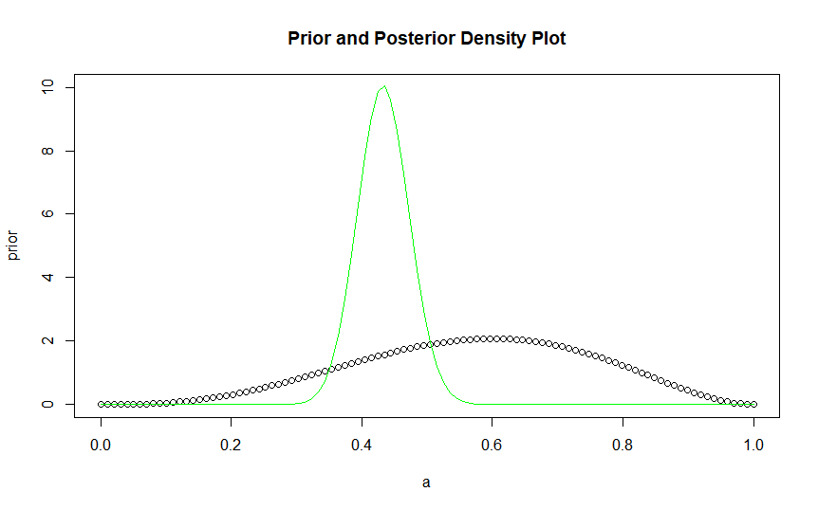

> # Interpretation: From the above graph we can see that the most dense area is from 0 to 6 which we take as an interval to evaluate the hpd region.

> k=seq(0,6,by=0.01)

> p=c()

> tmax=c()

> tmin=c()

> for(i in 1:length(k))

+ {

+ z=which(posterior>k[i])

+ t=a[z]

+ tmax[i]=max(t)

+ tmin[i]=min(t)

+ p[i]=pbeta(tmax[i],sum(x)+4,m*n-sum(x)+3)-pbeta(tmin[i],sum(x)+4,m*n-sum(x)+3)

+ }

> w=which(p>0.95)

> k1=k[w]

> m=max(k1)

> w1=which(k==m)

> tmax[w1]

[1] 0.5151515

> tmin[w1]

[1] 0.3535354

> #The value of theta lies between the interval tmin and tmax.

>

>

> ## Question 2 ##

> #Q2

> n=20

> theta=1.52

> x=rpois(n,theta)

> x

[1] 1 3 4 3 0 3 1 2 2 0 2 1 1 1 1 2 0 2 1 1

> a=seq(0,5,length=100);a

[1] 0.00000000 0.05050505 0.10101010 0.15151515 0.20202020 0.25252525 0.30303030 0.35353535 0.40404040 0.45454545

[11] 0.50505051 0.55555556 0.60606061 0.65656566 0.70707071 0.75757576 0.80808081 0.85858586 0.90909091 0.95959596

[21] 1.01010101 1.06060606 1.11111111 1.16161616 1.21212121 1.26262626 1.31313131 1.36363636 1.41414141 1.46464646

[31] 1.51515152 1.56565657 1.61616162 1.66666667 1.71717172 1.76767677 1.81818182 1.86868687 1.91919192 1.96969697

[41] 2.02020202 2.07070707 2.12121212 2.17171717 2.22222222 2.27272727 2.32323232 2.37373737 2.42424242 2.47474747

[51] 2.52525253 2.57575758 2.62626263 2.67676768 2.72727273 2.77777778 2.82828283 2.87878788 2.92929293 2.97979798

[61] 3.03030303 3.08080808 3.13131313 3.18181818 3.23232323 3.28282828 3.33333333 3.38383838 3.43434343 3.48484848

[71] 3.53535354 3.58585859 3.63636364 3.68686869 3.73737374 3.78787879 3.83838384 3.88888889 3.93939394 3.98989899

[81] 4.04040404 4.09090909 4.14141414 4.19191919 4.24242424 4.29292929 4.34343434 4.39393939 4.44444444 4.49494949

[91] 4.54545455 4.59595960 4.64646465 4.69696970 4.74747475 4.79797980 4.84848485 4.89898990 4.94949495 5.00000000

> prior=dgamma(a,2,2);prior

[1] 0.0000000000 0.1826108894 0.3301326954 0.4476222515 0.5394886031 0.6095708042 0.6612067440 0.6972940103

[9] 0.7203436833 0.7325278573 0.7357215993 0.7315399729 0.7213706913 0.7064028944 0.6876524964 0.6659844942

[17] 0.6421325898 0.6167164336 0.5902567679 0.5631887122 0.5358734089 0.5086082221 0.4816356588 0.4551511653

[25] 0.4293099312 0.4042328212 0.3800115375 0.3567131085 0.3343837830 0.3130524045 0.2927333287 0.2734289413

[33] 0.2551318251 0.2378266223 0.2214916282 0.2061001526 0.1916216787 0.1780228437 0.1652682686 0.1533212524

[41] 0.1421443536 0.1316998708 0.1219502382 0.1128583480 0.1043878085 0.0965031497 0.0891699815 0.0823551141

[49] 0.0760266445 0.0701540158 0.0647080528 0.0596609787 0.0549864158 0.0506593727 0.0466562220 0.0429546682

[57] 0.0395337104 0.0363735991 0.0334557896 0.0307628929 0.0282786246 0.0259877534 0.0238760491 0.0219302303

[65] 0.0201379143 0.0184875662 0.0169684507 0.0155705849 0.0142846929 0.0131021618 0.0120150001 0.0110157978

[73] 0.0100976886 0.0092543135 0.0084797869 0.0077686643 0.0071159117 0.0065168775 0.0059672647 0.0054631065

[81] 0.0050007418 0.0045767936 0.0041881481 0.0038319351 0.0035055100 0.0032064371 0.0029324736 0.0026815555

[89] 0.0024517833 0.0022414099 0.0020488287 0.0018725629 0.0017112549 0.0015636578 0.0014286258 0.0013051070

[97] 0.0011921355 0.0010888247 0.0009943612 0.0009079986

> posterior=dgamma(a,2+sum(x),n+2);posterior

[1] 0.000000e+00 8.015695e-34 1.133318e-24 1.609617e-19 5.274881e-16 2.191713e-13 2.466233e-11 1.126632e-09

[9] 2.660571e-08 3.795824e-07 3.639120e-06 2.529373e-05 1.348023e-04 5.748247e-04 2.027196e-03 6.069733e-03

[17] 1.575939e-02 3.610072e-02 7.401524e-02 1.374570e-01 2.335942e-01 3.664124e-01 5.344771e-01 7.297005e-01

[25] 9.377006e-01 1.139817e+00 1.316293e+00 1.449762e+00 1.528142e+00 1.546298e+00 1.506219e+00 1.415900e+00

[33] 1.287385e+00 1.134503e+00 9.708129e-01 8.080499e-01 6.552264e-01 5.183428e-01 4.005785e-01 3.027823e-01

[41] 2.240956e-01 1.625727e-01 1.157157e-01 8.088276e-02 5.556504e-02 3.754629e-02 2.497283e-02 1.636060e-02

[49] 1.056423e-02 6.727340e-03 4.227266e-03 2.622501e-03 1.607043e-03 9.731930e-04 5.826692e-04 3.450471e-04

[57] 2.021807e-04 1.172651e-04 6.734724e-05 3.831237e-05 2.159560e-05 1.206509e-05 6.682830e-06 3.670916e-06

[65] 2.000261e-06 1.081448e-06 5.802759e-07 3.090814e-07 1.634613e-07 8.585217e-08 4.478867e-08 2.321393e-08

[73] 1.195562e-08 6.119475e-09 3.113496e-09 1.574868e-09 7.920805e-10 3.961760e-10 1.970892e-10 9.753333e-11

[81] 4.801935e-11 2.352382e-11 1.146783e-11 5.564003e-12 2.687052e-12 1.291800e-12 6.182877e-13 2.946502e-13

[89] 1.398256e-13 6.608031e-14 3.110303e-14 1.458202e-14 6.810109e-15 3.168462e-15 1.468710e-15 6.783451e-16

[97] 3.121946e-16 1.431832e-16 6.544575e-17 2.981425e-17

> plot(a,prior,ylim=c(0,2),main="Prior and Posterior Density Plot")

> lines(a,posterior,col="orange")

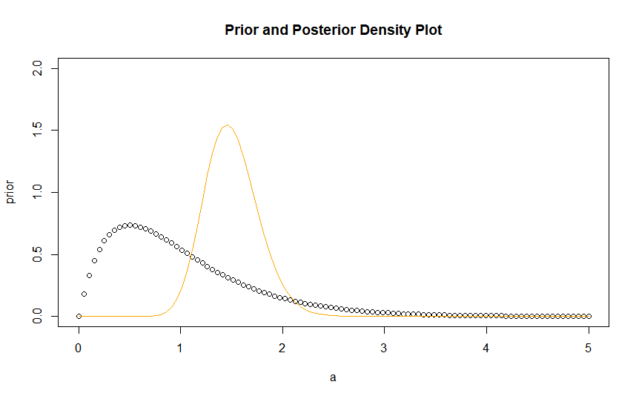

> # Interpretation: From the above graph we can see that the most dense area is from 0 to 1 which we take as an interval to evaluate the hpd region.

>

> k=seq(0,1,by=0.01)

> p=c()

> tmax=c()

> tmin=c()

> for(i in 1:length(k))

+ {

+ z=which(posterior>k[i])

+ t=a[z]

+ tmax[i]=max(t)

+ tmin[i]=min(t)

+ p[i]=pgamma(tmax[i],2+sum(x),n+2)-pgamma(tmin[i],2+sum(x),n+2)

+ }

> t

[1] 1.262626 1.313131 1.363636 1.414141 1.464646 1.515152 1.565657 1.616162 1.666667

> p

[1] 1.0000000 0.9980805 0.9951291 0.9935699 0.9885549 0.9885549 0.9851443 0.9851443 0.9799281 0.9750087 0.9750087

[12] 0.9750087 0.9680373 0.9680373 0.9588168 0.9588168 0.9588168 0.9491197 0.9491197 0.9491197 0.9491197 0.9491197

[23] 0.9491197 0.9358916 0.9208962 0.9208962 0.9208962 0.9208962 0.9208962 0.9208962 0.9208962 0.9032178 0.9032178

[34] 0.9032178 0.9032178 0.9032178 0.9032178 0.8806047 0.8806047 0.8806047 0.8806047 0.8574834 0.8574834 0.8574834

[45] 0.8574834 0.8574834 0.8574834 0.8574834 0.8574834 0.8574834 0.8574834 0.8574834 0.8279236 0.8279236 0.7960883

[56] 0.7960883 0.7960883 0.7960883 0.7960883 0.7960883 0.7960883 0.7960883 0.7960883 0.7960883 0.7960883 0.7960883

[67] 0.7591937 0.7591937 0.7591937 0.7591937 0.7591937 0.7591937 0.7591937 0.7171043 0.7171043 0.7171043 0.7171043

[78] 0.7171043 0.7171043 0.7171043 0.7171043 0.6722087 0.6722087 0.6722087 0.6722087 0.6722087 0.6722087 0.6722087

[89] 0.6722087 0.6722087 0.6722087 0.6722087 0.6722087 0.6722087 0.6196793 0.6196793 0.6196793 0.6196793 0.5664958

[100] 0.5664958 0.5664958

>

> w=which(p>0.95)

> k1=k[w]

> m=max(k1)

> w1=which(k==m)

> tmax[w1]

[1] 2.070707

> tmin[w1]

[1] 1.010101

> #The value of theta lies between the interval tmin and tmax.

> ## Question 3 ##

> n=30

> theta=2.6

> x=rnorm(n,theta,1);x

[1] 5.0499422 2.7032922 3.6055604 2.8837579 2.6576072 3.5698656 2.1130704 1.9923355 2.3667862 0.7493914 1.9908793

[12] 3.5359100 2.3764075 2.9427675 3.5040618 2.9460293 3.1176286 4.5441842 2.3393960 3.5294364 3.3305450 3.0568204

[23] 3.1432087 2.4399325 3.2475512 1.1686289 2.3831079 1.1547734 3.9753132 3.9610458

> a=seq(-10,10,length=100);a

[1] -10.0000000 -9.7979798 -9.5959596 -9.3939394 -9.1919192 -8.9898990 -8.7878788 -8.5858586 -8.3838384

[10] -8.1818182 -7.9797980 -7.7777778 -7.5757576 -7.3737374 -7.1717172 -6.9696970 -6.7676768 -6.5656566

[19] -6.3636364 -6.1616162 -5.9595960 -5.7575758 -5.5555556 -5.3535354 -5.1515152 -4.9494949 -4.7474747

[28] -4.5454545 -4.3434343 -4.1414141 -3.9393939 -3.7373737 -3.5353535 -3.3333333 -3.1313131 -2.9292929

[37] -2.7272727 -2.5252525 -2.3232323 -2.1212121 -1.9191919 -1.7171717 -1.5151515 -1.3131313 -1.1111111

[46] -0.9090909 -0.7070707 -0.5050505 -0.3030303 -0.1010101 0.1010101 0.3030303 0.5050505 0.7070707

[55] 0.9090909 1.1111111 1.3131313 1.5151515 1.7171717 1.9191919 2.1212121 2.3232323 2.5252525

[64] 2.7272727 2.9292929 3.1313131 3.3333333 3.5353535 3.7373737 3.9393939 4.1414141 4.3434343

[73] 4.5454545 4.7474747 4.9494949 5.1515152 5.3535354 5.5555556 5.7575758 5.9595960 6.1616162

[82] 6.3636364 6.5656566 6.7676768 6.9696970 7.1717172 7.3737374 7.5757576 7.7777778 7.9797980

[91] 8.1818182 8.3838384 8.5858586 8.7878788 8.9898990 9.1919192 9.3939394 9.5959596 9.7979798

[100] 10.0000000

> prior=dnorm(a,1,1);prior

[1] 2.118819e-27 1.915713e-26 1.662810e-25 1.385576e-24 1.108392e-23 8.512006e-23 6.275467e-22 4.441562e-21

[9] 3.017872e-20 1.968527e-19 1.232700e-18 7.410529e-18 4.276774e-17 2.369512e-16 1.260309e-15 6.435329e-15

[17] 3.154568e-14 1.484515e-13 6.706636e-13 2.908710e-12 1.211076e-11 4.840812e-11 1.857549e-10 6.842866e-10

[25] 2.419977e-09 8.215990e-09 2.677837e-08 8.378837e-08 2.516859e-07 7.257878e-07 2.009259e-06 5.339954e-06

[33] 1.362432e-05 3.337086e-05 7.846855e-05 1.771329e-04 3.838650e-04 7.986073e-04 1.595010e-03 3.058224e-03

[41] 5.629249e-03 9.947345e-03 1.687483e-02 2.748192e-02 4.296654e-02 6.448952e-02 9.292303e-02 1.285385e-01

[49] 1.706940e-01 2.176101e-01 2.663271e-01 3.129156e-01 3.529510e-01 3.821881e-01 3.972972e-01 3.964873e-01

[57] 3.798556e-01 3.493681e-01 3.084776e-01 2.614805e-01 2.127799e-01 1.662254e-01 1.246636e-01 8.975477e-02

[65] 6.203701e-02 4.116420e-02 2.622189e-02 1.603555e-02 9.414107e-03 5.305788e-03 2.870756e-03 1.491139e-03

[73] 7.435590e-04 3.559494e-04 1.635824e-04 7.217062e-05 3.056749e-05 1.242895e-05 4.851600e-06 1.818071e-06

[81] 6.540518e-07 2.258858e-07 7.489303e-08 2.383797e-08 7.284045e-09 2.136739e-09 6.017358e-10 1.626806e-10

[89] 4.222223e-11 1.052015e-11 2.516393e-12 5.778436e-13 1.273848e-13 2.695880e-14 5.477205e-15 1.068299e-15

[97] 2.000333e-16 3.595731e-17 6.205084e-18 1.027977e-18

> post=dnorm(a,((1+sum(x))/(n+1)),sqrt(1/(n+1)));post

[1] 0.000000e+00 0.000000e+00 0.000000e+00 0.000000e+00 0.000000e+00 0.000000e+00 0.000000e+00 0.000000e+00

[9] 0.000000e+00 0.000000e+00 0.000000e+00 0.000000e+00 0.000000e+00 0.000000e+00 0.000000e+00 0.000000e+00

[17] 0.000000e+00 0.000000e+00 0.000000e+00 0.000000e+00 0.000000e+00 0.000000e+00 0.000000e+00 0.000000e+00

[25] 0.000000e+00 0.000000e+00 0.000000e+00 0.000000e+00 0.000000e+00 0.000000e+00 8.036317e-308 1.025919e-289

[33] 3.695809e-272 3.757048e-255 1.077766e-238 8.724546e-223 1.992975e-207 1.284699e-192 2.336907e-178 1.199561e-164

[41] 1.737575e-151 7.102407e-139 8.192343e-127 2.666560e-115 2.449261e-104 6.348329e-94 4.643274e-84 9.583627e-75

[49] 5.581823e-66 9.174087e-58 4.254908e-50 5.568756e-43 2.056680e-36 2.143462e-30 6.303847e-25 5.231618e-20

[57] 1.225200e-15 8.096895e-12 1.509978e-08 7.946272e-06 1.180040e-03 4.945051e-02 5.847704e-01 1.951374e+00

[65] 1.837538e+00 4.882842e-01 3.661421e-02 7.747600e-04 4.626210e-06 7.795143e-09 3.706496e-12 4.973286e-16

[73] 1.883059e-20 2.011987e-25 6.066343e-31 5.161421e-37 1.239231e-43 8.396066e-51 1.605240e-58 8.660537e-67

[81] 1.318531e-75 5.664690e-85 6.867564e-95 2.349470e-105 2.268181e-116 6.179112e-128 4.750234e-140 1.030492e-152

[89] 6.308335e-166 1.089747e-179 5.312231e-194 7.307501e-209 2.836622e-224 3.107239e-240 9.604802e-257 8.378047e-274

[97] 2.062233e-291 1.432430e-309 0.000000e+00 0.000000e+00

> plot(a,prior,ylim=c(0,3),main="Prior and Posterior Density Plot")

> lines(a,post,col="orange")

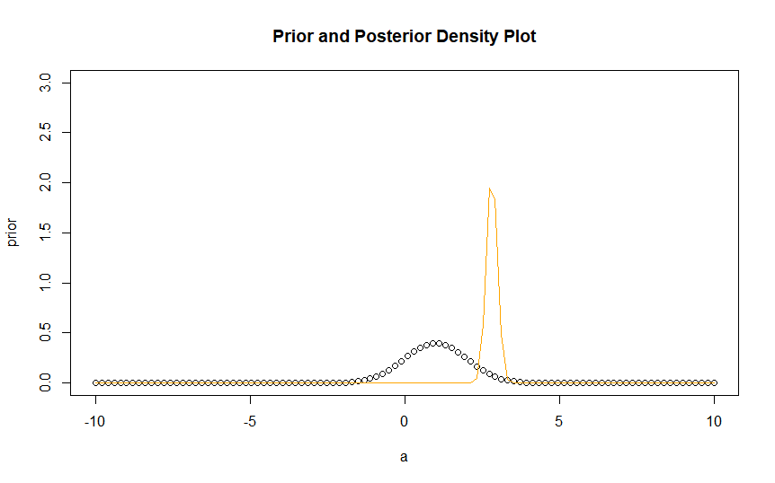

> # Interpretation: From the above graph we can see that the most dense area is from 0 to 1 which we take as an interval to evaluate the hpd region.

> k=seq(0,1,by=0.01)

> p=c()

> tmax=c()

> tmin=c()

> for(i in 1:length(k))

+ {

+ z=which(post>k[i])

+ t=a[z]

+ tmax[i]=max(t)

+ tmin[i]=min(t)

+ p[i]=pnorm(tmax[i],((1+sum(x))/(n+1)),sqrt(1/(n+1)))-pnorm(tmin[i],((1+sum(x))/(n+1)),sqrt(1/(n+1)))

+ }

> w=which(p>0.95)

> k1=k[w]

> m=max(k1)

> w1=which(k==m)

> tmax[w1]

[1] 3.131313

> tmin[w1]

[1] 2.323232

> # The value of theta lies between the interval tmin and tmax.

> ## Question 4 ##

> n=30

> x=runif(n,-2.2,2.2);x

[1] -1.0340253 -0.0503917 -1.3781900 2.0495867 -1.3721021 1.8571116 2.0475883 1.4057038 0.8996609 -1.4613148

[11] -0.9082957 -0.1394292 -1.7719600 0.1081640 -1.3559943 0.4151658 1.6470167 1.3107294 -0.6383412 0.5424704

[21] -0.7161315 0.1771868 -0.9821733 0.1087809 1.6421345 -0.1287437 1.6973074 -1.6623019 0.1842494 -0.7918319

> t=max(-x1,xn,1)

> x1=min(x)

> xn=max(x)

> a=seq(t,5,length=100);

> prior=2/(a^3)

> post=((n+2)*t^(n+2))/(a^(n+3));post

[1] 1.469319e+01 9.566329e+00 6.262778e+00 4.122119e+00 2.727392e+00 1.813810e+00 1.212270e+00 8.141746e-01

[9] 5.494099e-01 3.724668e-01 2.536552e-01 1.735082e-01 1.191990e-01 8.223549e-02 5.696908e-02 3.962534e-02

[17] 2.767084e-02 1.939772e-02 1.364966e-02 9.640536e-03 6.833693e-03 4.861295e-03 3.470239e-03 2.485690e-03

[25] 1.786426e-03 1.288087e-03 9.317494e-04 6.761140e-04 4.921316e-04 3.593003e-04 2.631019e-04 1.932220e-04

[33] 1.423087e-04 1.051057e-04 7.784279e-05 5.780782e-05 4.304370e-05 3.213417e-05 2.405133e-05 1.804705e-05

[41] 1.357530e-05 1.023648e-05 7.737342e-06 5.862127e-06 4.451680e-06 3.388296e-06 2.584707e-06 1.976049e-06

[49] 1.513999e-06 1.162464e-06 8.944265e-07 6.896154e-07 5.327854e-07 4.124459e-07 3.199172e-07 2.486286e-07

[57] 1.935952e-07 1.510274e-07 1.180381e-07 9.242347e-08 7.249766e-08 5.696866e-08 4.484430e-08 3.536118e-08

[65] 2.793082e-08 2.209875e-08 1.751333e-08 1.390197e-08 1.105302e-08 8.801828e-09 7.020092e-09 5.607656e-09

[73] 4.486210e-09 3.594418e-09 2.884163e-09 2.317632e-09 1.865067e-09 1.503009e-09 1.212935e-09 9.802005e-10

[81] 7.932055e-10 6.427505e-10 5.215279e-10 4.237249e-10 3.447104e-10 2.807902e-10 2.290127e-10 1.870169e-10

[89] 1.529110e-10 1.251777e-10 1.025980e-10 8.419155e-11 6.916870e-11 5.689264e-11 4.684918e-11 3.862260e-11

[97] 3.187637e-11 2.633774e-11 2.178536e-11 1.803940e-11

> plot(a,prior,ylim=c(0,20))

> lines(a,post,col="blue")

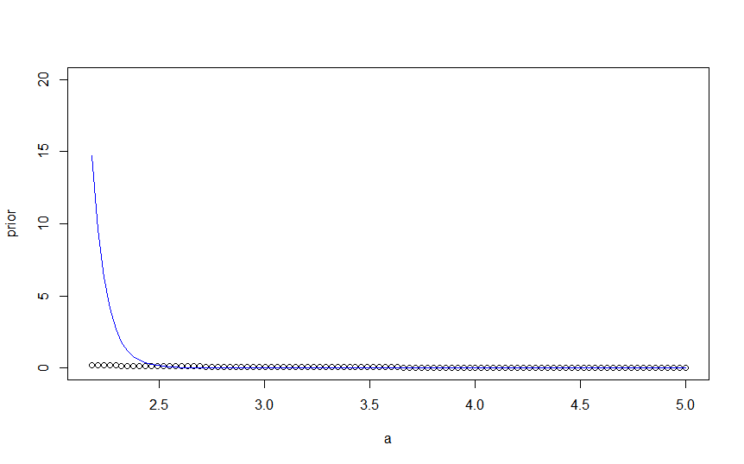

> Interpretation: From the above graph we can see that the most dense area is from 0 to 10 which we take as an interval to evaluate the hpd region.

>

> k=seq(0,10,by=0.01)

> p=c()

> tmax=c()

> tmin=c()

> g=n+3

> s=n+2

> for(i in 1:length(k))

+ {

+ z=which(post>k[i])

+ t=a[z]

+ tmax[i]=max(t)

+ tmin[i]=min(t)

+ p[i]=s*(t^s)*((tmin[i]^(1-g))-(tmax[i]^(1-g)))/(s)

+ }

> t

[1] 2.177879

> w=which(p>0.95)

> k1=k[w]

> m=max(k1)

> w1=which(k==m)

> tmax[w1]

[1] 2.40593

> tmin[w1]

[1] 2.177879

> #The value of theta lies between the interval tmin and tmax.

>